**Library Management System**

**Pre-requisites**: User Login, Entry of books into the database as purchased from the vendor.

**Assumptions:**

* It’s the user accessing the project.
* This module is independent in functionality and not currently integrated with other modules in the LIBRARY MANAGEMENT SYSTEM. Hence, wherever necessary, data has been accepted from the user. In ideal case, the data shall be passed by the LOGIN module.

**Objective Accomplished using this module**:

* Issue of books available in the database.
* Creating a record of the transaction in user transaction table.
* Removing issued book from the list of available books.

**Database tables used:**

* ZMASTERBOOK_XXX
* ZTRANS_USERXXX linked to the above table by a foreign key relationship.

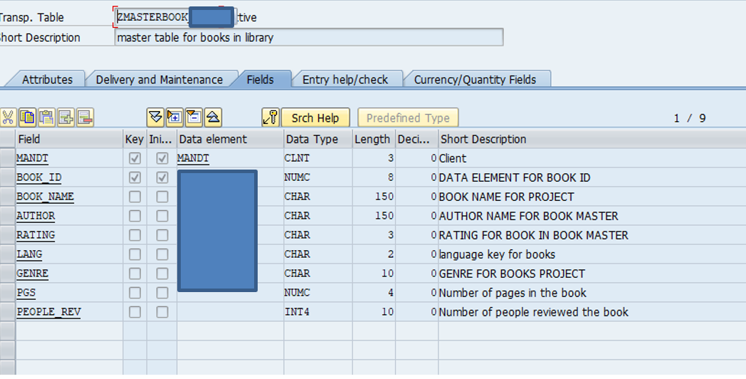

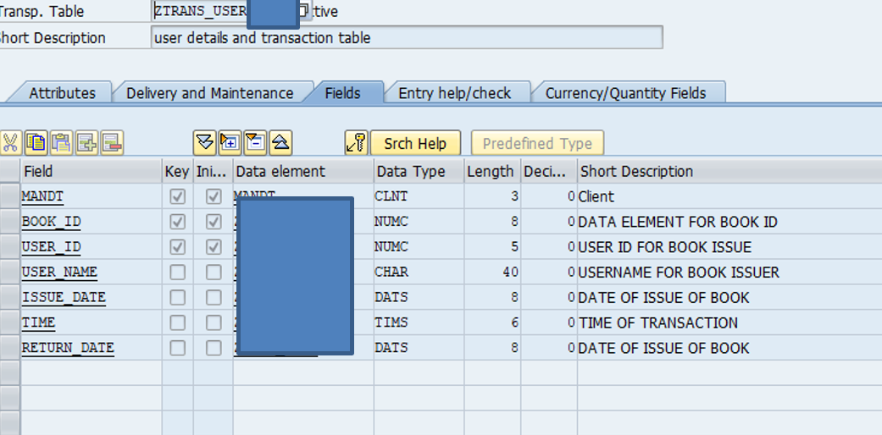

**Functionality of module:**

**1st Screen:**

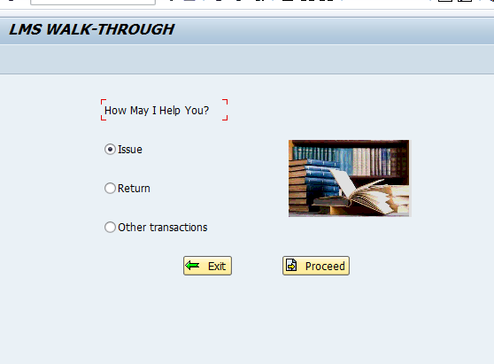

* Pressing **Exit** makes you leave the program.
* Pressing **Proceed** takes you forward to the next screen.
* Since this module covers only issue of books, a dialog box pops up if either of **Return** or **Other transactions** radio buttons are chosen.

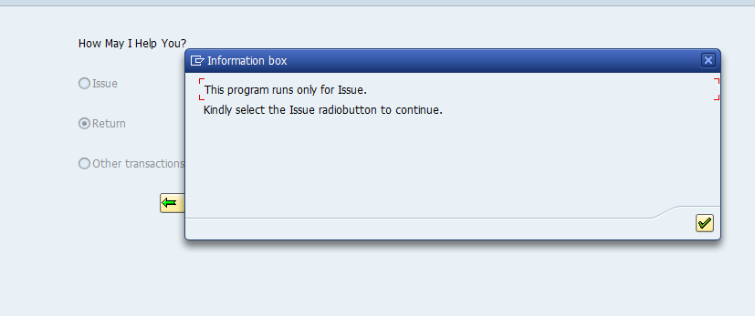

**2nd Screen:**

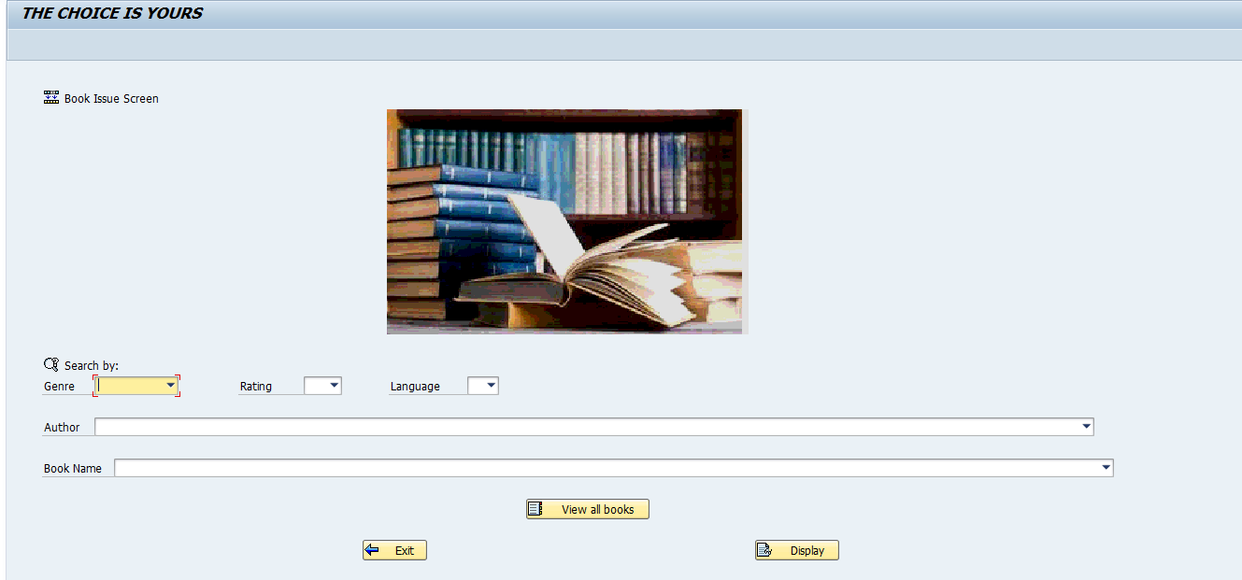

* Here, the user can filter data (available books- ones that can be issued) according to his/her choice. The filtering can be done taking any and all combinations of the mentioned fields, namely- **Genre, Rating, Language, Author, Book Name.**
* **Exit** lets you go back to previous page.
* **View all Books** lists all the available books in the database.
* **Display** helps the user display the list of books as per his filtering choice.

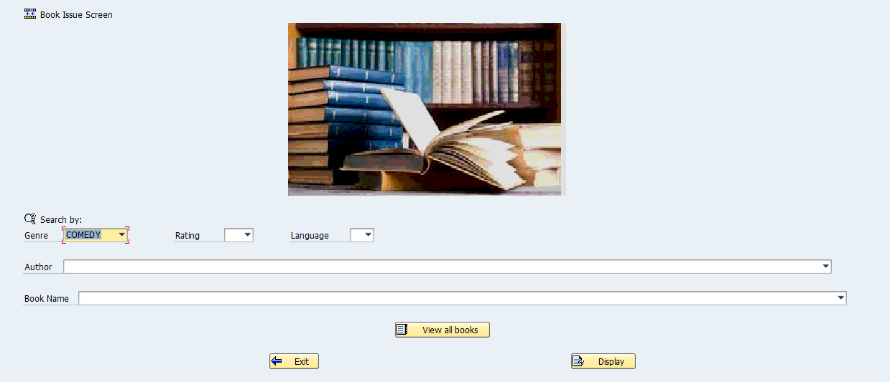

**3rd Screen:**

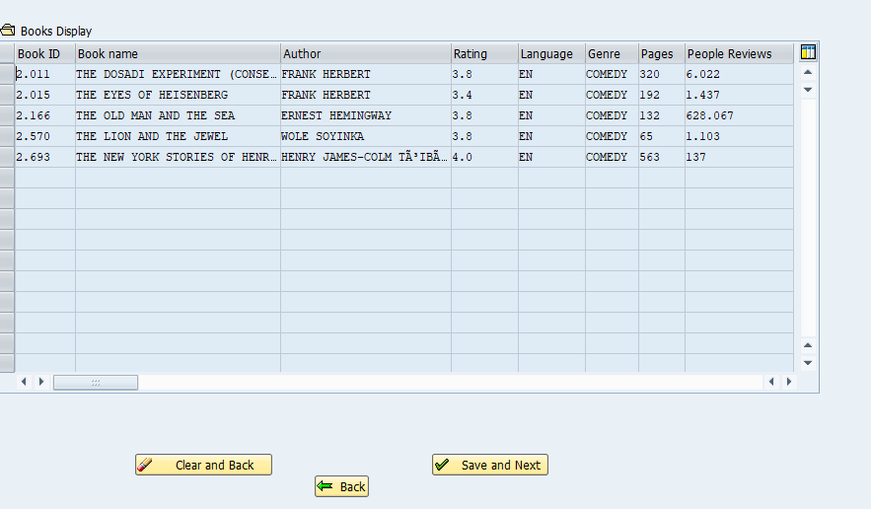

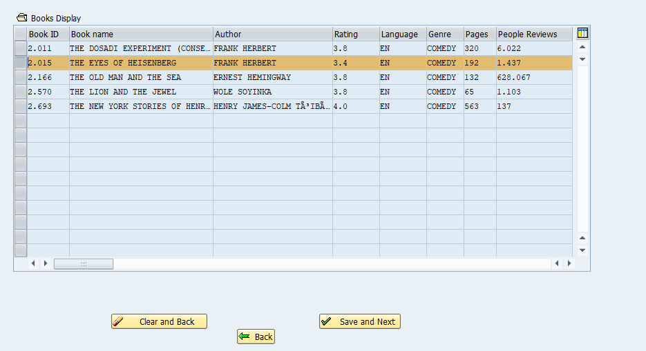

* This screen lets you select a single line at a time and perform one of the three options presented:
* **Save and Next :** Lets the user save his selection and move to next screen.

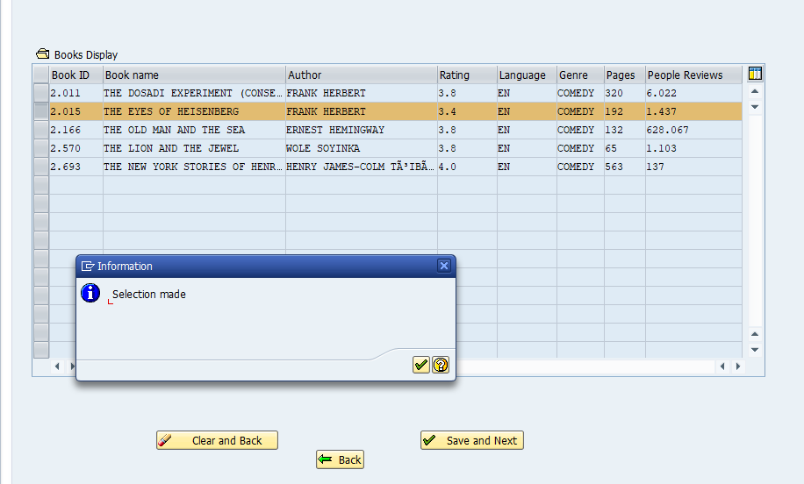

* **Back :** Lets the user go back to the previous screen so as to edit his possible filters without removing or deleting his previous selection.

**(**on setting a new filter condition coming from 4th screen after going back, eg: Author- JK Rowling, both filtered conditions of comedy and JK rowling are shown)

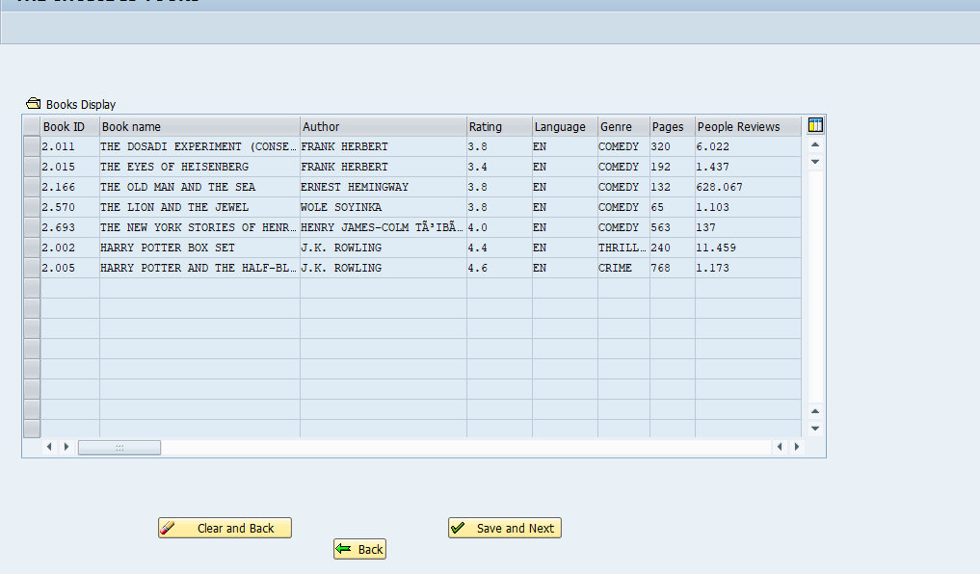

* **Clear and back:** lets the user clear any and all of his selections and lands him to the previous screen.

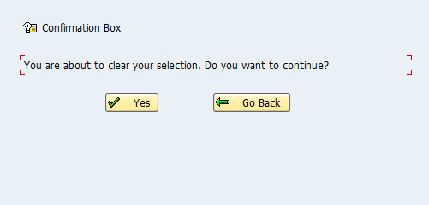

**4th Screen:**

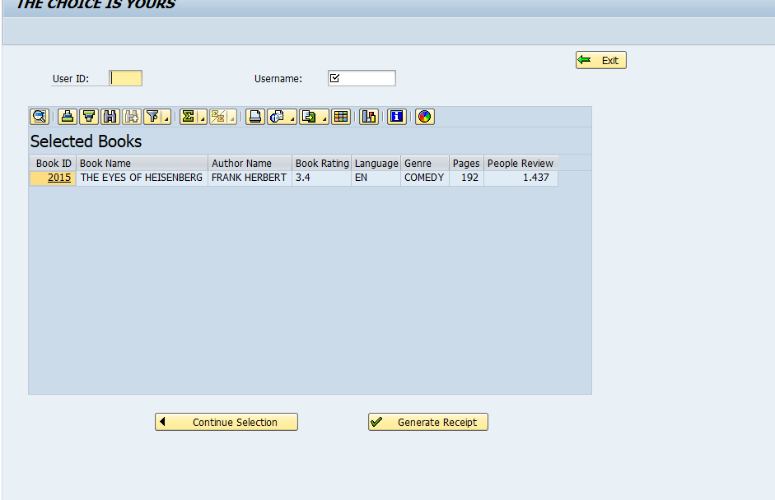

**User Id and Username are mandatory fields.**

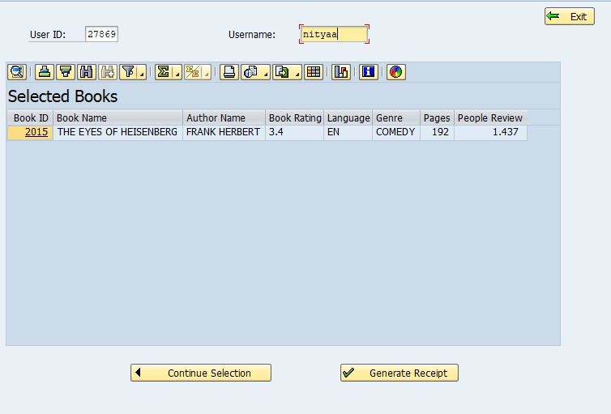

* **Continue Selection:** Takes the user back to previous screen (3rd) so as to add more selections to the list of books to be issued.

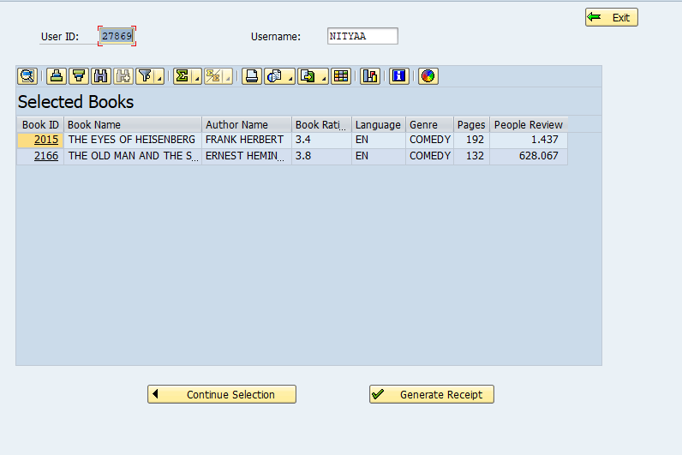

* **Generate Receipt:** Generates an adobe form with the issue transaction details.

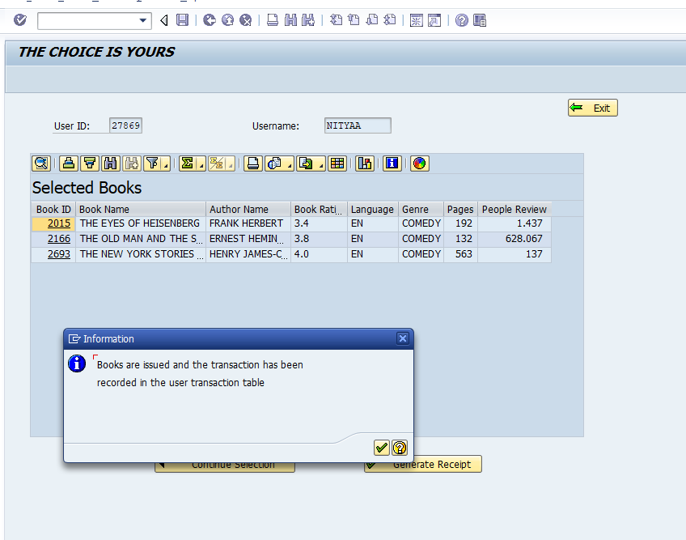

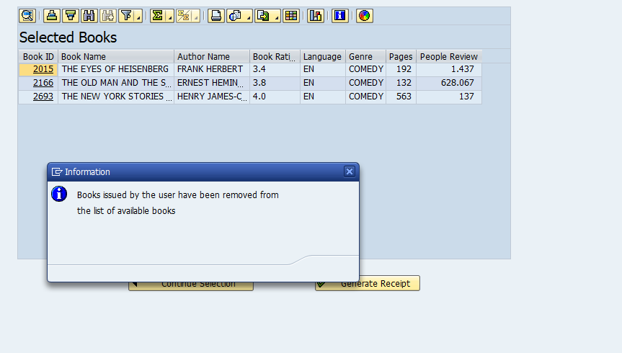

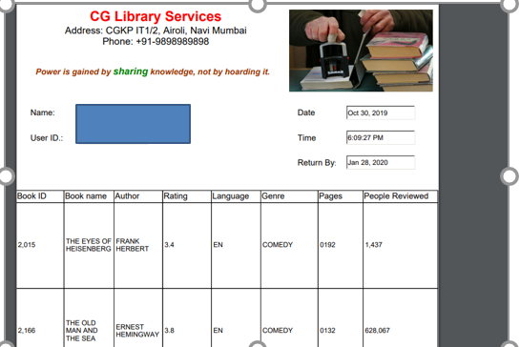

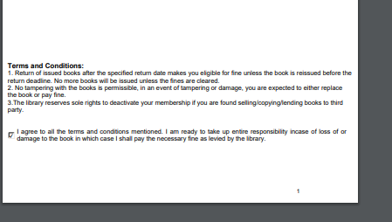

Updated transaction table with the list of bookid’s issued on a particular user id.

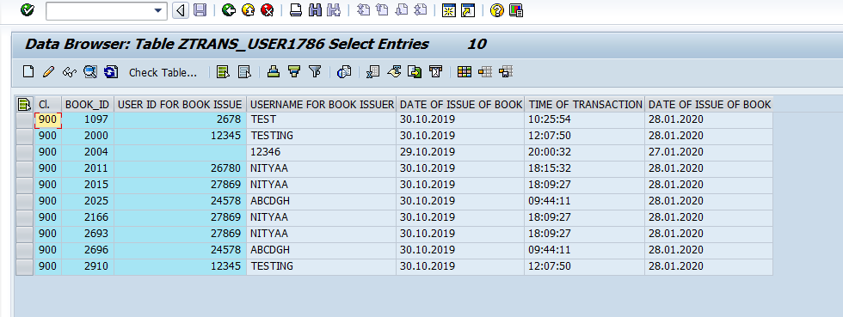

**Contents of Table containing list of available books.**

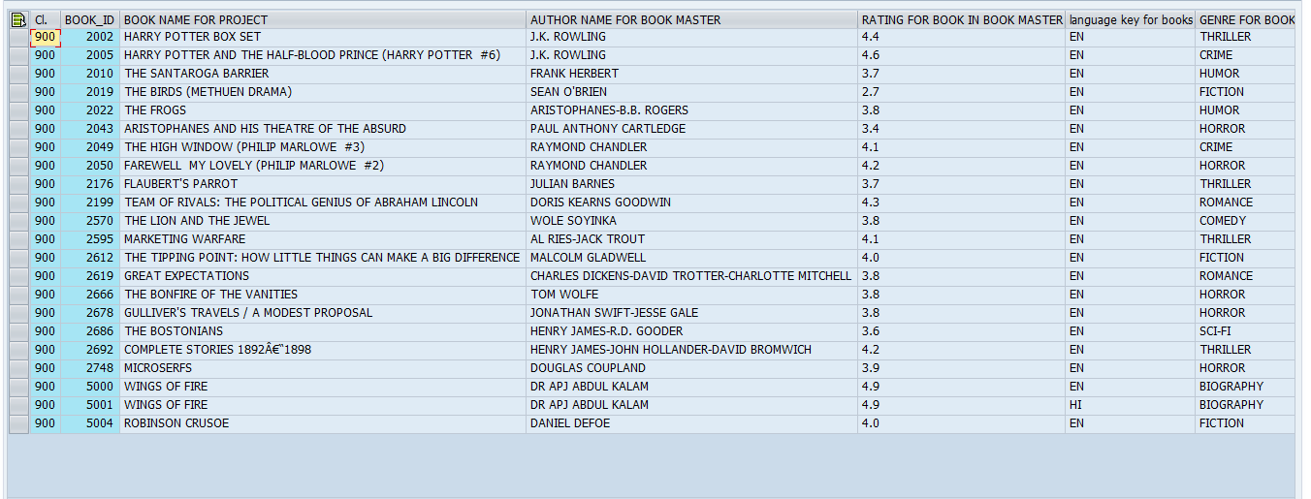

**The book ids that are issued have been removed from this table.**